H.T No
Regulations:
A17

Sreenidhi Institute of Science and Technology
(An Autonomous Institution)
Code No: 6AC46 Date: 19-July-2021(AN)

B.Tech IV-Year I- Semester Covid-19 Special External Examination, July - 2021 (Regular)
LINEAR CONTROL SYSTEMS (ECE)

Time: 3 Hours Max.Marks:75

Note: a) No additional answer sheets will be provided.
b) All sub-parts of a question must be answered at one place only, otherwise it will not be valued.
c) Missing data can be assumed suitably.

ANSWER ANY 5 OUT OF 8 QUESTIONS. EACH QUESTION CARRIES 15 MARKS.

Bloom's Cognitive Levels of Learning (BCLL)

Remember | L1 | Apply | L3 | Evaluate | L5
Understand | L2 | Analyze | L4 | Create | L6

 |  |  | BCLL | CO(s) | Marks
1. |  | Write the differential equations governing the system shown in below figure. Also draw the Torque-Voltage analogous electrical circuit?  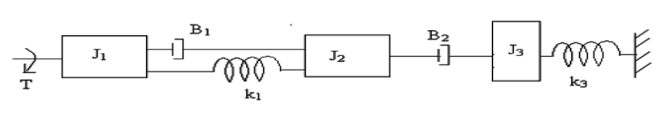 | L4 | CO1 | [15M]
2. | a) | Discuss the effect of PD and PI on performance of a control system. | L3 | CO2 | [8M]
 | b) | A unity feed back system is characterized by an open loop transfer function  Determine the gain K so that the system will have a damping factor of 0.7. For this value of K determine the natural frequency of the system. It is subjected to a unity step input. Obtain the closed loop response of the system in time domain. | L4 | CO2 | [7M]
3. |  | Using R-H criterion, determine the stability of a system representing characteristic equation  and comment on location of roots of characteristic equation. | L5 | CO3 | [15M]
4. |  | A feedback system has Draw bode plot and comment on stability. | L4 | CO4 | [15M]
5. | a) | Derive the expression for the transfer function of a lead compensator | L3 | CO5 | [8M]
 | b) | What are the effects of phase – lead compensation? | L2 | CO5 | [7M]
6. |  | Explain the importance of  i) controllability and observability ii) state transition matrix  iii) diagnolization of the control system model in the design of the control system. | L1 | CO6 | [15M]
7. | a) | Explain the construction and principle of operation synchro transmitter. | L2 | CO1 | [8M]
 | b) | Explain the working of AC servo motor and find its transfer function? | L2 | CO2 | [7M]
8. | a) | Derive expression for the transfer function of a Lead compensator. | L4 | CO4 | [8M]
 | b) | Explain PID controller. | L1 | CO5 | [7M]
-- 00 -- 00 –

